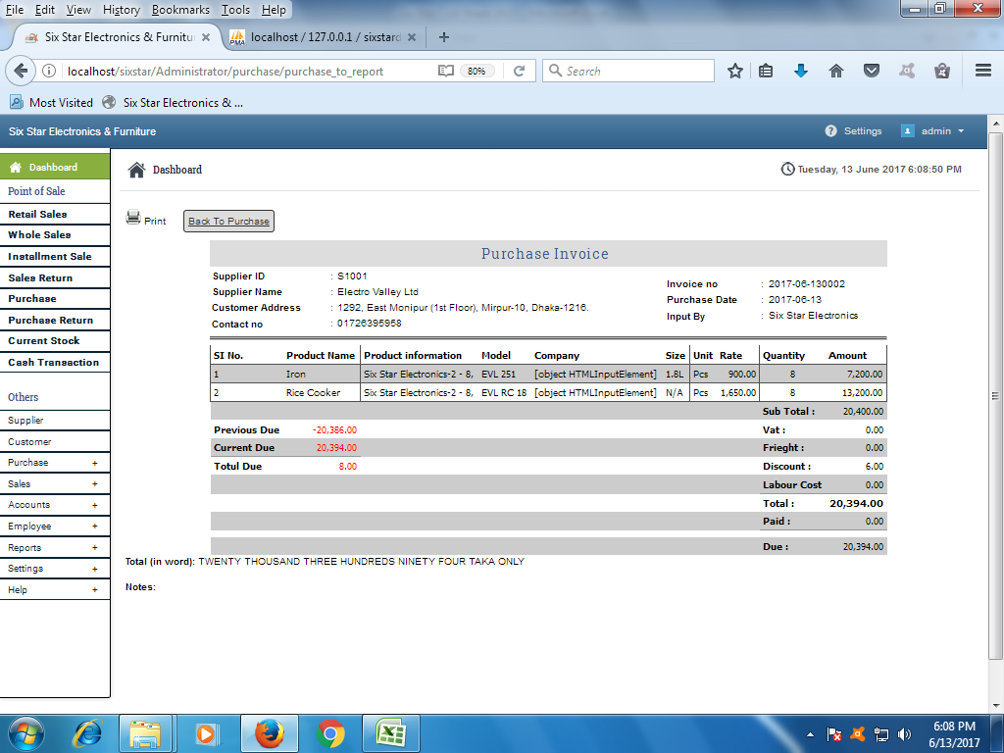

**Due Purchase figure Problem**

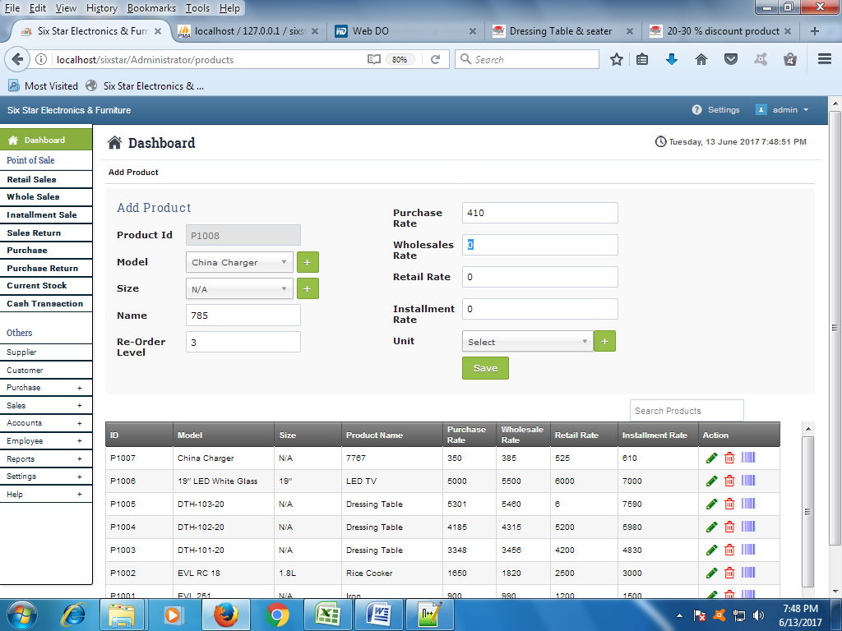

Need Input box for

Whole sale rate= Purchase + Wholesale%

Retail sale rate= Purchase + Retail%

Installment sale rate= Retail + installment%

**ALL FIGURE WILL BE EDITABLE & MUST DECRISE DECIMEL FIGURE (0.01 TO 0.4 =0.0 ELSE 1.0)**

Table Arrangement:

|  |  |  |  |  |  |  |  |  |  |
| --- | --- | --- | --- | --- | --- | --- | --- | --- | --- |
| ID | Company | Product name | Model | Size | Purchase rate | Wholesale rate | Retail rate | Installment rate | Action |

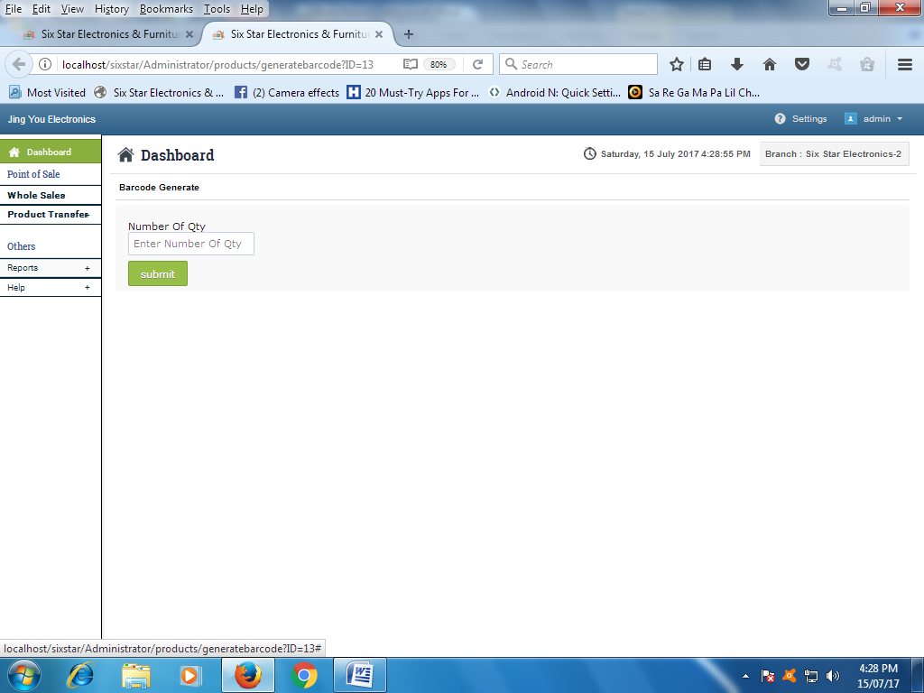

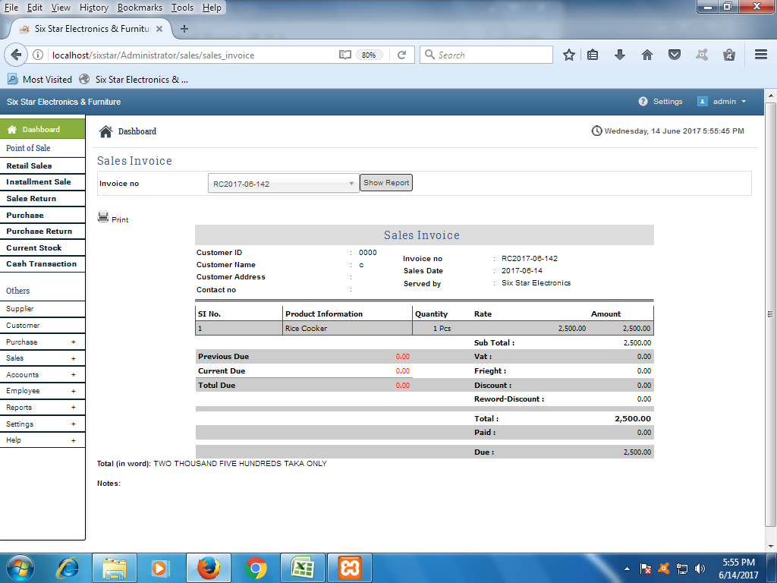

Previous Due Sales Figure Problem

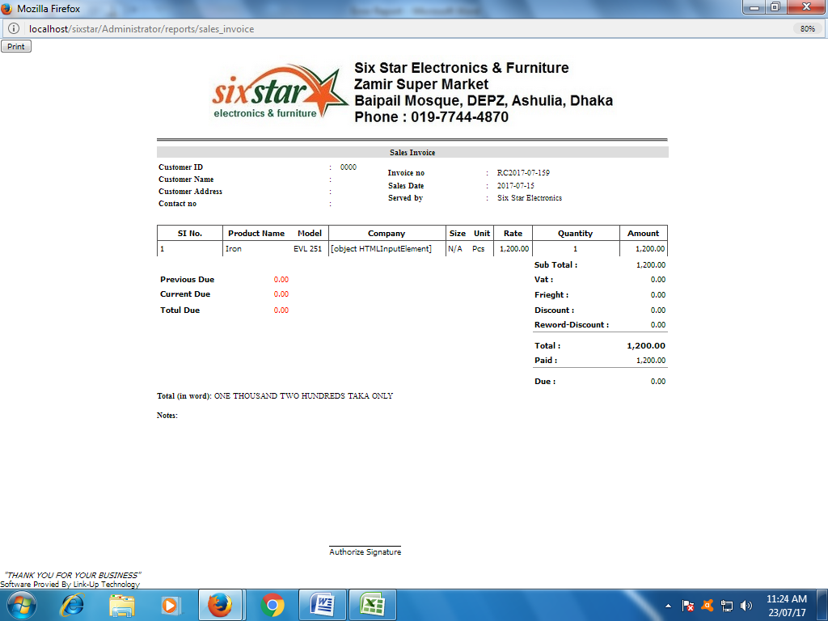

In Word: One Thousand Two Hundreds Tk. Only

Authorize by

Checked & Delivery by

Cash Received by

Purchase by

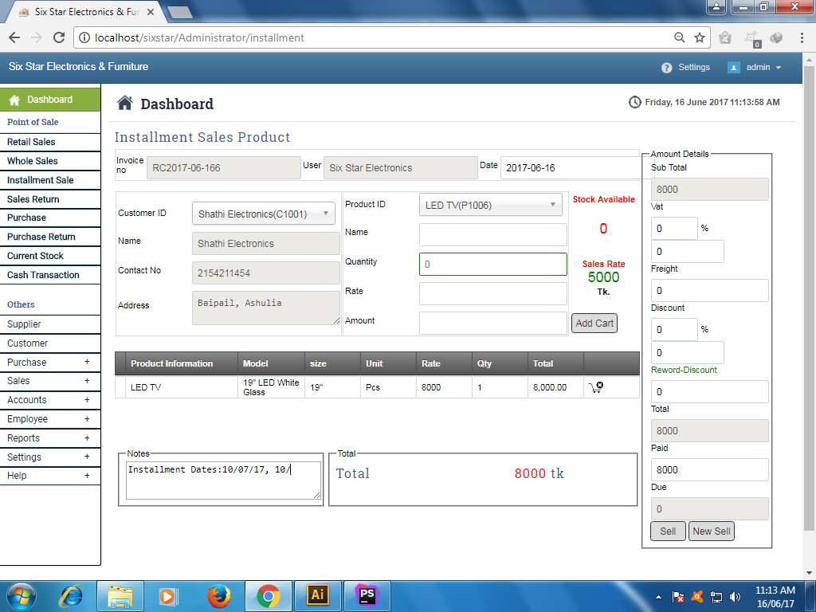

No’s of Installment

Installment rate

Down payment

No Need

If Retail & wholesale then here show Purchase Rate Else, Retail Sales

Need to added **Down payment, No’s of installment & installment rate.**

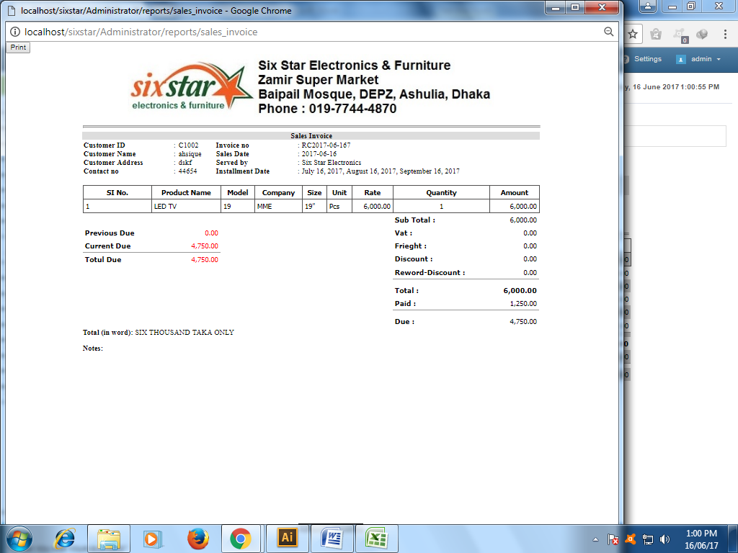

Installment Date: Next month’s 1-15 Date

Table arrangement:

|  |  |  |  |  |  |  |  |  |
| --- | --- | --- | --- | --- | --- | --- | --- | --- |
| Sl No. | Product name | Company | Model | Size | Qty | Rate | Total | Remarks |

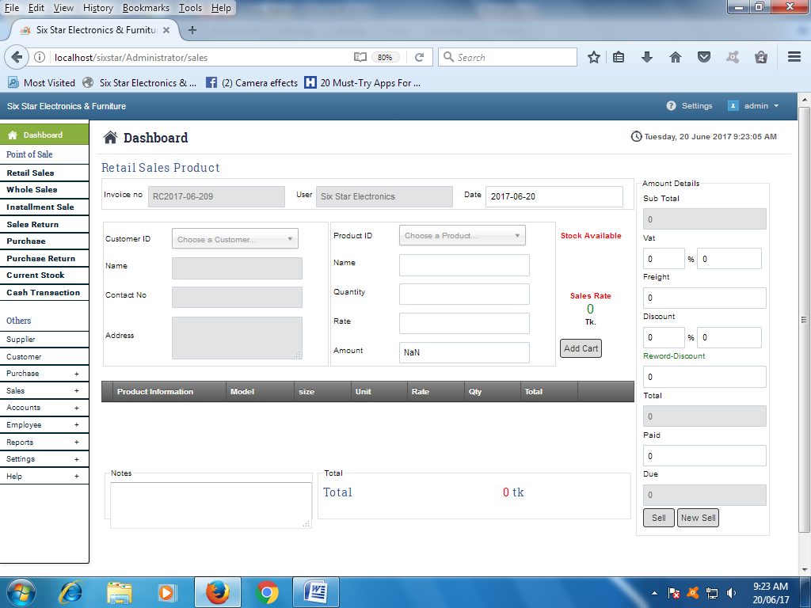

Dis%

No need Dis %

Just Amount

Actual rate

(Rate – Dis%) *Qty

We’ve needed discount % for any single products & also need all text boxes will be editable.

No General Customer, Customer ID generate automatically, all text box have visibility & editable permission & Every Customer will be Stored with his own ID.

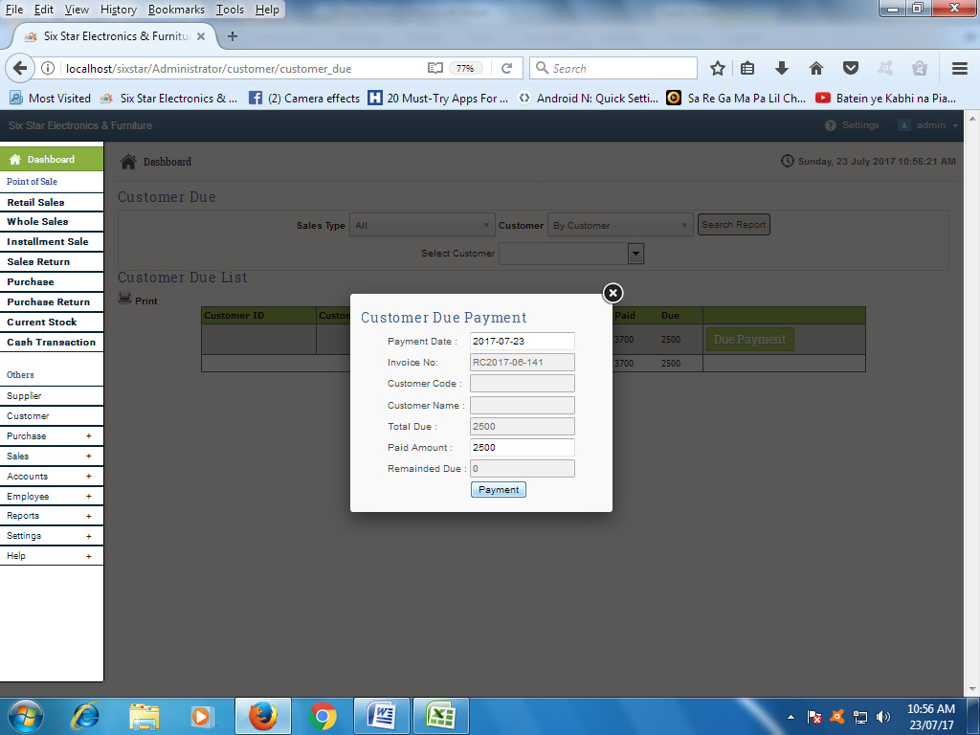

For Customer Due Payment and Supplier Due Payment:

After Payment need a print copy with current status. 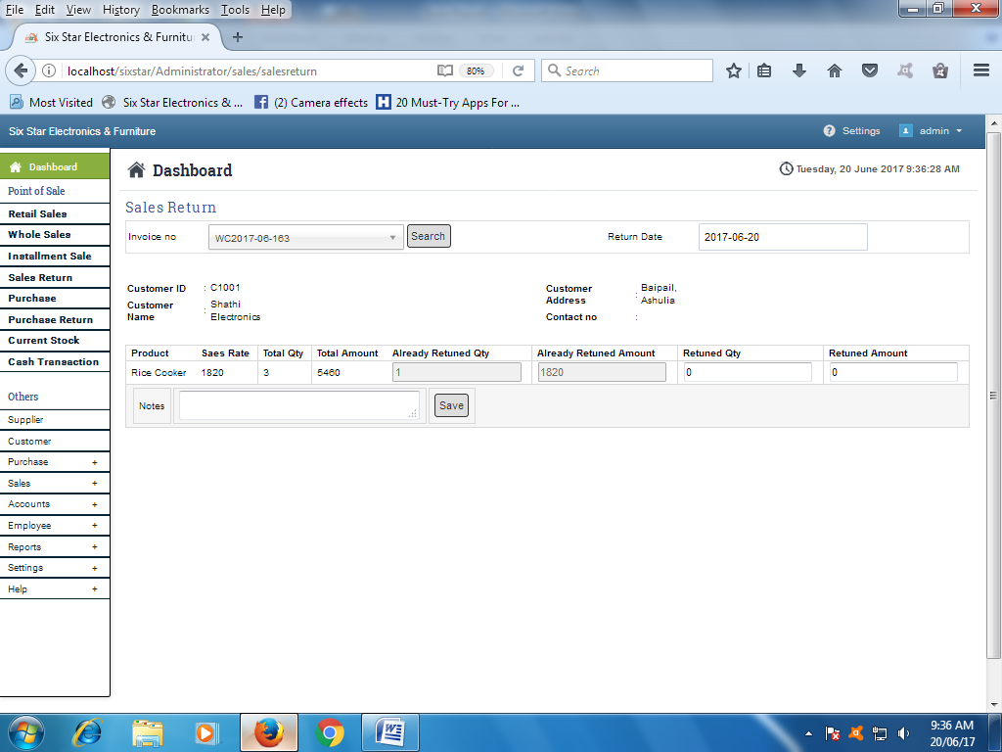

Need a print copy for Sales Return & Purchase Return.

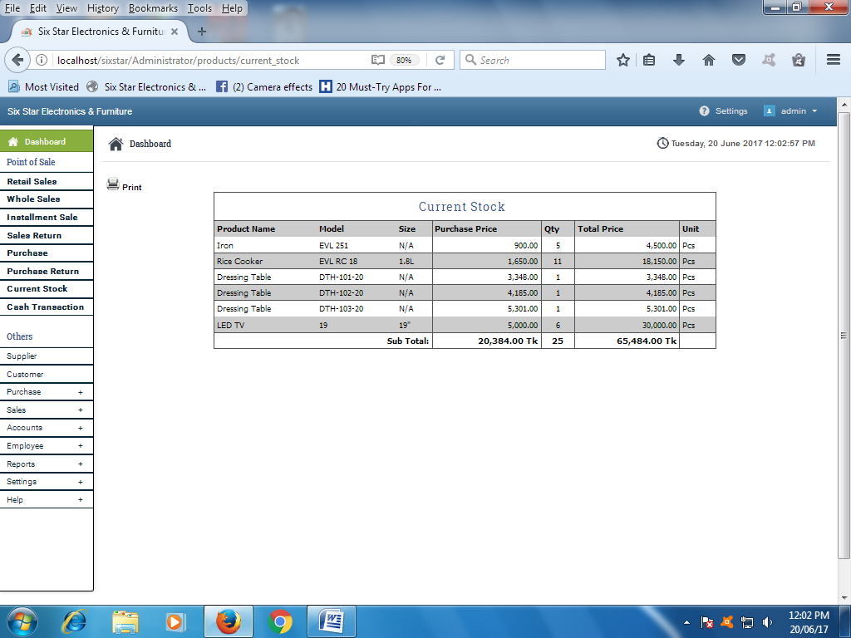

Everywhere needed Company name with Model

Table arrangement:

|  |  |  |  |  |  |  |  |
| --- | --- | --- | --- | --- | --- | --- | --- |
| Sl No | Product name | Company | Model | Size | Qty | Purchase Price | Total Price |

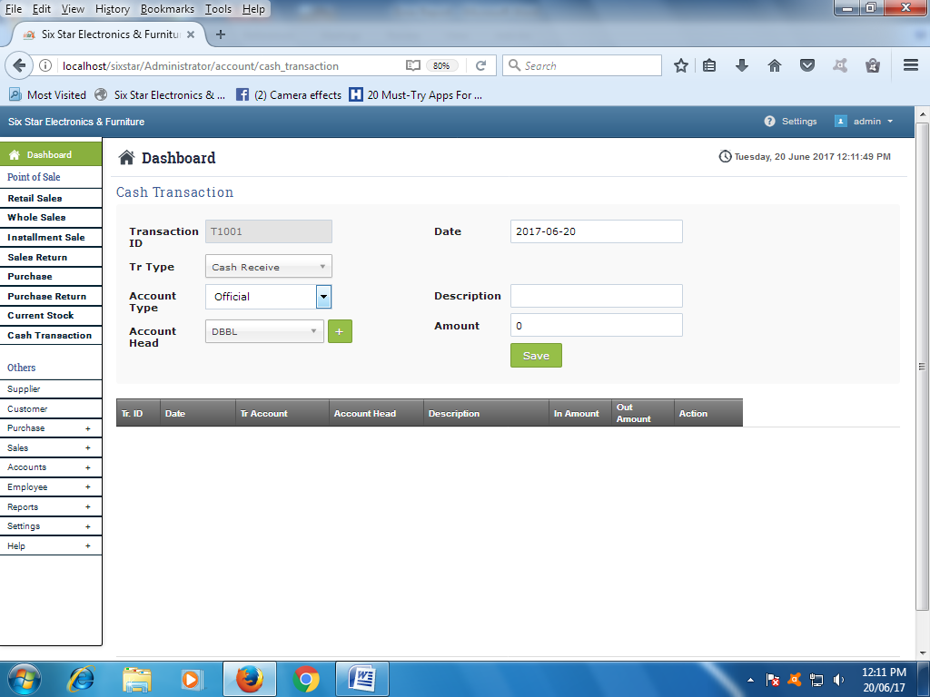

Calculate IOU & Banking Balance with the same Account’s Head & Description.

And this report will be calculate deferent’s Month wise with current status.

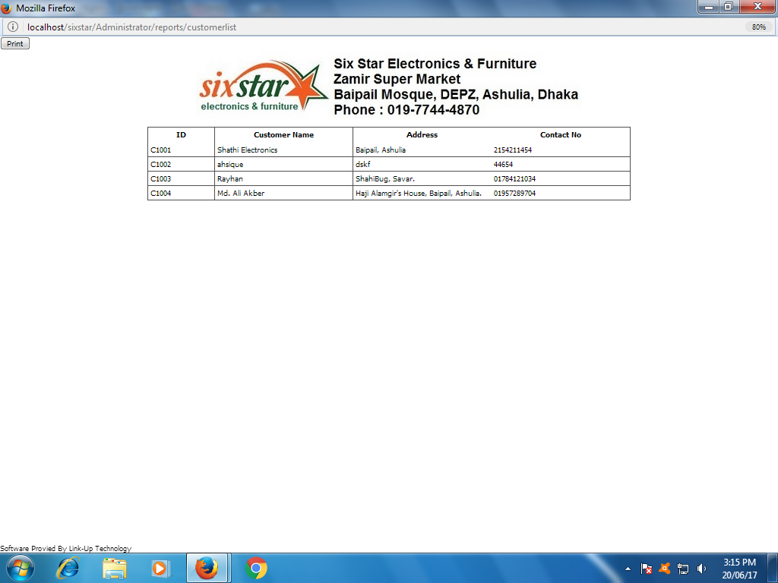

Need Print option for Customer’s Due status & Details with photo & NID.

**User Management not work properly**

**Administrator:**

The user can check & Update any type data or control anything

**Normal User:**

The users can’t Access Sales return, Purchase return & Loss & Profit Summary.

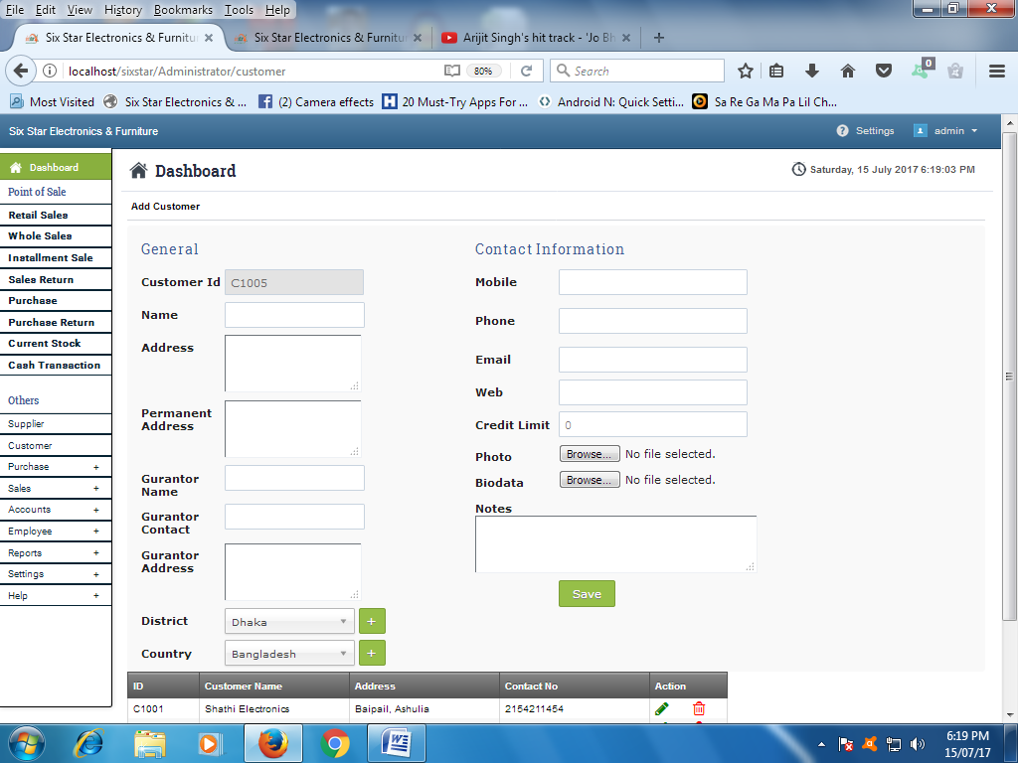

**Photo Viewer**

40 mm x 50 mm

Resizable image frame

Photo Path: [http://localhost/sixstar/uploads/customer/“customerid”.jpg](http://localhost/sixstar/uploads/customer/)

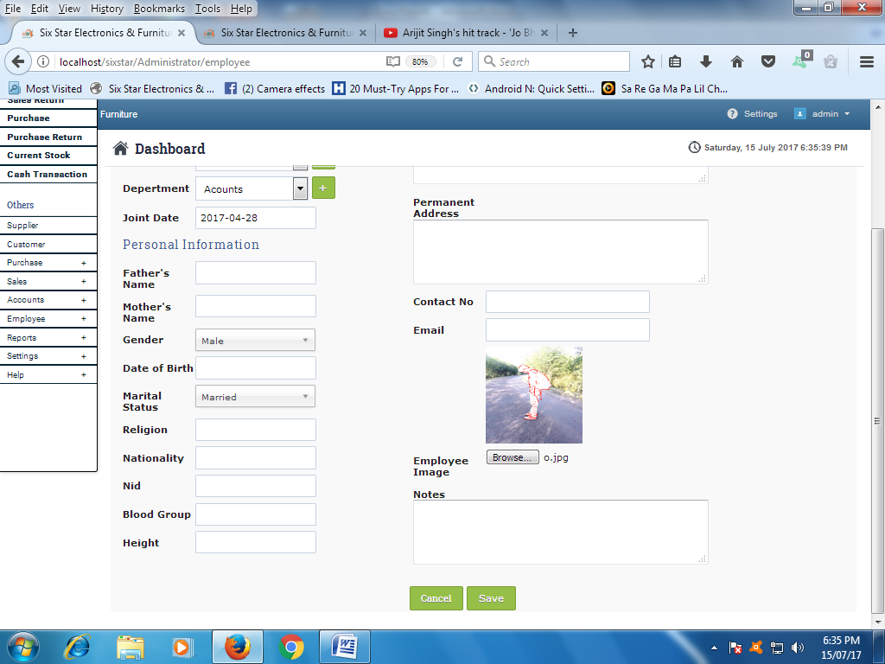

1.9” X 1.6”  
Photo resizable Frame

Date Format: dd/mm/yyyy;

Salary Structure, Marital status: if married need Spouse Name else nothing.

Religion & Blood Group: Drop down menu with add button.

[http://localhost/sixstar/uploads/employeePhoto/“employeeId”.jpg](http://localhost/sixstar/uploads/employeePhoto/)

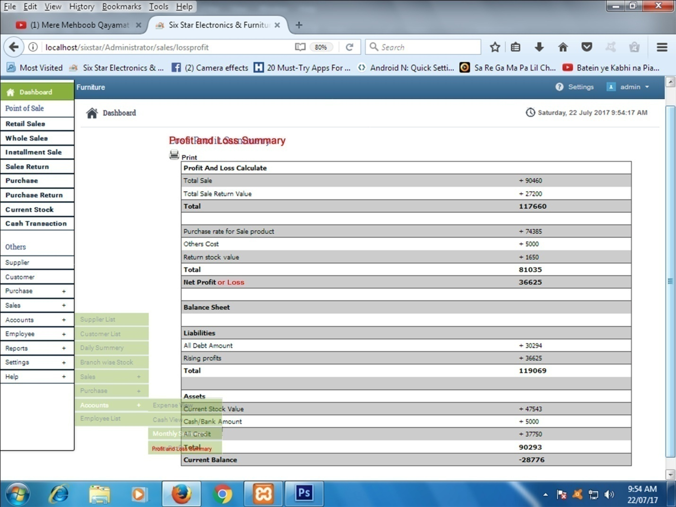

Correct the Red mark text.

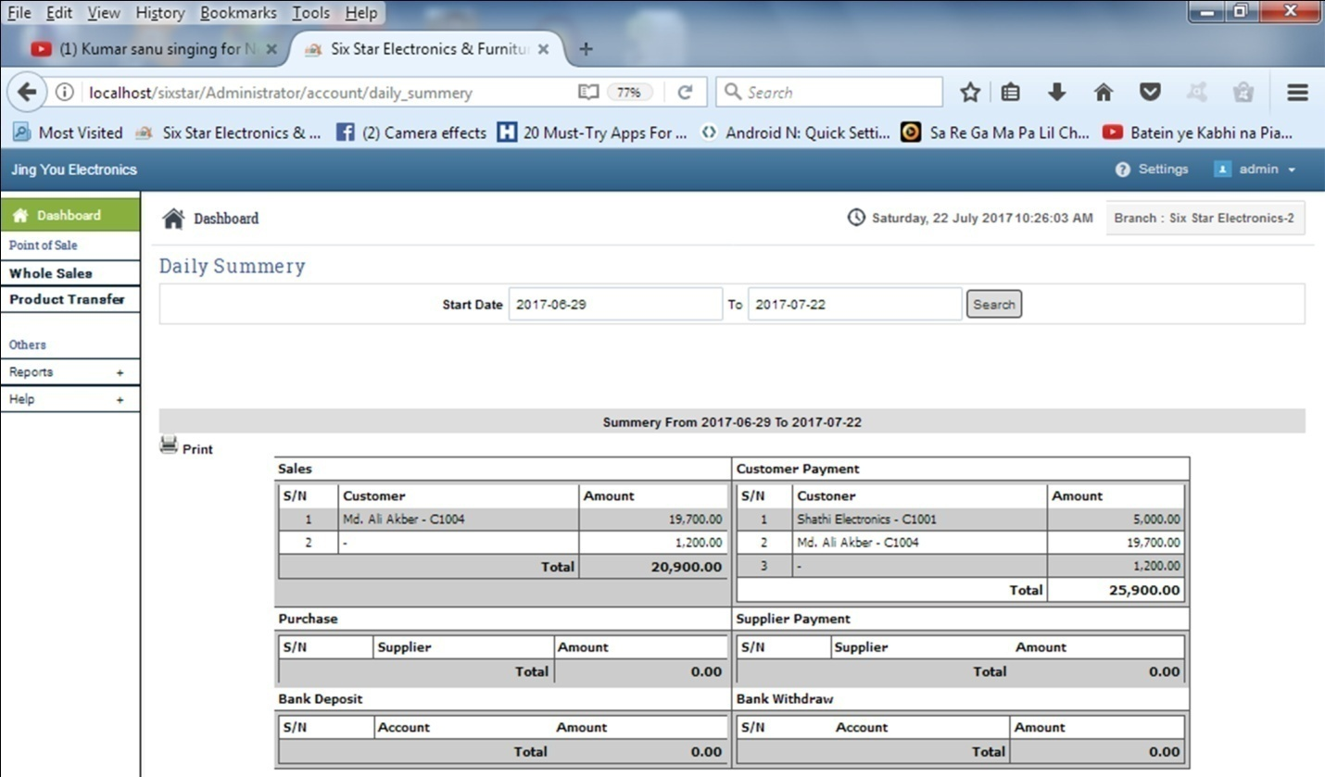

|  |  |  |  |  |  |  |  |
| --- | --- | --- | --- | --- | --- | --- | --- |
| **Sales** | | | | | **Expense** | | |
| **Sl. No** | **Sales Type** | | | **Amount** | **Sl. No** | **Expense Type** | **Amount** |
| 01. | Total Retail Sale | | | 00.00 | 01. | Total Purchase | 00.00 |
| 02. | Total Whole Sale | | | 00.00 | 02. | Supplier Payment | 00.00 |
| 03. | Total Installment Sale | | | 00.00 | 03. | General Expense | 00.00 |
| Sub Total | | | | x,xx,xxx.00 | 04. | Other’s Payment | 00.00 |
| 01. | Total Retail Sale in Cash | | | 00.00 | Sub Total | | x,xx,xxx.00 |
| 02. | Total Whole Sale in Cash | | | 00.00 | 01. | Bank Deposit | 00.00 |
| 03. | Total Down Payment | | | 00.00 |  |  |  |
| 04. | Total Due Amount Received | | | 00.00 |  |  |  |
| 05. | Total Installment Amount Received | | | 00.00 |  |  |  |
| 06. | Bank Withdraw | | | 00.00 |  |  |  |
| 07. | Other’s Received | | | 00.00 |  |  |  |
| Sub Total | | | | x,xx,xxx.00 |  |  |  |
| **Balance Cash** | | | **Balance Bank** | |
| **Opening** | | **00.00** | **Opening** | **00.00** |
| **Closing** | | **00.00** | **Closing** | **00.00** |
| **Total Party Due** | | | **00.00** | |
| **Total Supplier Due** | | | **00.00** | |

Need a new Page for Service

* [Dashboard](http://localhost/sixstar/Administrator)

**Point of Sale**

* + [**Retail Sales**](http://localhost/sixstar/Administrator/sales)
  + [**Whole Sales**](http://localhost/sixstar/Administrator/wholesales)
  + [**Installment Sale**](http://localhost/sixstar/Administrator/installment)
  + [**Sales Return**](http://localhost/sixstar/Administrator/sales/salesreturn)
  + [**Purchase**](http://localhost/sixstar/Administrator/purchase/order)
  + [**Purchase Return**](http://localhost/sixstar/Administrator/purchase/returns)
  + [**Current Stock**](http://localhost/sixstar/Administrator/products/current_stock)
  + [**Cash Transaction**](http://localhost/sixstar/Administrator/account/cash_transaction)

**Others**

* + [Supplier](http://localhost/sixstar/Administrator/supplier)
  + [Customer](http://localhost/sixstar/Administrator/customer)
  + [Purchase](http://localhost/sixstar/Administrator.php)
  + [Sales](http://localhost/sixstar/Administrator.php)
  + [Accounts](http://localhost/sixstar/Administrator.php)
  + [Employee](http://localhost/sixstar/Administrator.php)
  + [**Service**](http://localhost/sixstar/Administrator/Service.php)

|  |  |  |  |  |  |  |
| --- | --- | --- | --- | --- | --- | --- |
| **Sl. No** | **Name** | **Address** | **Contact No.** | **Company** | **Products** | **Problem** |
| 01. | Ushar Alo | Baipail | +66566230 | Minister | M-252 Fridge | Not cooling on Normal |
|  |  |  |  |  |  |  |

Add

|  |  |  |  |  |  |  |  |
| --- | --- | --- | --- | --- | --- | --- | --- |
| Sl. No | Name | Address | Contact No. | Company | Products | Problem | Status |
| 01. | Ushar Alo | Baipail | +66566230 | Minister | M-252 Fridge | Not cooling on Normal  Delivered |  |
|  |  |  |  |  |  |  |  |

In Status need List box

Under List box: OK

Not Ok

Defaults Status: Not OK

If ok show Delivered Button and after delivered need a print copy.